
VASIREDDY VENKATADRI INSTITUTE OF TECHNOLOGY NAMBUR-522508 ANDHRA PRADESH, INDIA
YEAR : IV B.Tech SEMESTER: I
COURSE NAME: Operations Research
COURSE CODE:
BRANCH: CSE (Artificial intelligence and machine learning)
PREREQUISITE: Nil
COURSE OBJECTIVE:
1. To understand the basics of linear programming, transportation, queueing, sequencing of jobs, replacement, inventory, and simulation problems.
2. To apply linear programming, transportation, and assignment models to solve real life problems.
3. To apply Sequencing, queueing, Game and Replacement theories to solve problems.
4. Apply knowledge of inventory control and simulation to solve practical industrial problems.
COURSE OUTCOMES: Students will be able to:
SN | OUTCOME |  | Cognitive Levels as per Bloom’s Taxonomy | Weightage (%)
CO1 | The understand the basics of linear programming {Understand level, KL2} |  | L1, L2, L3 | 20
CO2 | To apply transportation, and assignment models to solve real life problems.{Apply level, KL3} |  | L1, L2, L3 | 20
CO3 | To apply queuing and sequencing theories to solve real life problems. {Apply level, KL3} |  | L1, L2, L3 | 20
CO4 | To Recognize and solve replacement and game theory problems. {Apply level, KL3} |  | L1, L2, L3 | 20
CO5 | The Model the project management problems through CPM and PERT. {Apply level, KL3} |  | L1, L2, L3, L4 | 20
WEIGHTAGE OFBLOOM’S LEGENDS & PERCENTAGEOF QUESTIONS IN EXAMINATIONS:
L1 (Remembering) = 10-20 % L2 (Understanding) = 10-15 %
L3 (Applying) = 50-60 % L4 (Analysing) = 10-20 %
Easy (%) = 15% - 20% Average (%)= 60% - 70% Difficult(%)=15% - 20%
TOTAL = L1 + L2 + L3 + L4 = 100% (on an average about 2minutes per mark)
Note: This specification weightage in above shall be treated as a general guideline for students, teachers and paper setters. The actual distribution of marks in the question paper may vary slightly.
DETAILED SYLLABUS:
UNIT-1:
INTRODUCTION TO OPERATIONS RESEARCH: History, definition, operations research models, phases of implementing operations research in practice, applications.
LINEAR PROGRAMMING: Introduction, formulation, graphical solution, simplex method, Big M and two-phase methods, duality principle.

UNIT-II:
TRANSPORTATION: Introduction to the problem, LP formulation of a transportation problem. Basic feasible solution by north-west corner method, Vogel's approximation method, least cost method.
ASSIGNMENT: One to one assignment problem, optimal solutions, unbalanced assignment matrix, travelling salesman problem, maximization in A.P.

UNIT-III:
QUEUING THEORY: Introduction, Kendall’s notation, classification of queuing models, single server and multi-server models, Poisson arrival, exponential service, infinite population.
SEQUENCING: Introduction, assumptions, processing n-jobs through two machines, n-jobs through three machines, and graphic solution for processing 2 jobs through n machines with different order of sequence.

UNIT-IV:
GAME THEORY: Introduction, game with pure strategies, game with mixed strategies, dominance principle, graphical method for 2xn and mx2 games. REPLACEMENT THEORY: Introduction, replacement of items that deteriorate with time - value of money unchanging and changing, simple probabilistic model for replacement of items that fail completely.

UNIT-V:
NETWORK ANALYSIS: Project planning, scheduling, and controlling – tools for project management – critical path method – Programme evaluation and review technique (PERT) – cost analysis and crashing – resource levelling – updating.

TEXTBOOKS:
1.Operations Research, by S.D. Sharma, Kedarnath & Ramnath publications (15th edition),2013.
2.Introduction to Operations Research, by Taha, Pearson Education, New Delhi, (8th edition), 2008.

REFERENCEBOOKS:
1.Operations Research, (4th edition) by A.M. Natarajan, P. Balasubramani, A. Tamilarasi, Pearson Education, New Delhi, 2009.
2.Operations Research, (2nd edition) by R. Panner Selvam, 2009, PHI Publications, Noida.
3.Operations Research, (2nd edition) by Wagner, 2007, PHI Publications, Noida
4.Operation Research, (4th edition) by J.K. Sharma, 2009, Macmillan publishers, India Ltd. New Delhi.

ONLINE REFERENCES: NIL

MICRO-SYLLABUS:

Unit | Module | Micro content
1 | Introduction to Operations Research | History and Definition.
1 | Introduction to Operations Research | operations research models
1 | Introduction to Operations Research | phases of implementing operations research in practice
1 | Introduction to Operations Research | Applications of Operations research
1 | Linear Programming | Introduction, formulation
1 | Linear Programming | graphical solution
1 | Linear Programming | simplex method,
1 | Linear Programming | Big M
1 | Linear Programming | two-phase methods
1 | Linear Programming | duality principle
Unit | Module | Microcontent
2 | Transportation | Introduction to the problem
2 | Transportation | LP formulation of a transportation problem.
2 | Transportation | Basic feasible solution by north-west corner method
2 | Transportation | Basic feasible solution by Vogel's approximation method
2 | Transportation | Basic feasible solution by least cost method.
2 | Assignment | One to one assignment problem,
2 | Assignment | optimal solutions
2 | Assignment | unbalanced assignment matrix
2 | Assignment | travelling salesman problem
2 | Assignment | maximization in A.P.
3 | Queuing Theory | Introduction
3 | Queuing Theory | Kendall’s notation
3 | Queuing Theory | classification of queuing models
3 | Queuing Theory | single server and multi-server models
3 | Queuing Theory | Poisson arrival
3 | Queuing Theory | exponential service
3 | Queuing Theory | infinite population
3 | Sequencing | Introduction, assumptions
3 | Sequencing | Processing n-jobs through two machines
3 | Sequencing | Processing n-jobs through three machines
3 | Sequencing | graphic solution for processing 2 jobs through n machines with different order of sequence
4 | Game Theory | Introduction
4 | Game Theory | game with pure strategies
4 | Game Theory | game with mixed strategies
4 | Game Theory | dominance principle
4 | Game Theory | graphical method for 2xn games
4 | Game Theory | graphical method for mx2 games
4 | Replacement Theory | Introduction
4 | Replacement Theory | replacement of items that deteriorate with time - value of money unchanging
4 | Replacement Theory | replacement of items that deteriorate with time - value of money changing
4 | Replacement Theory | simple probabilistic model for replacement of items that fail completely
5 | Network Analysis | Project planning
5 | Network Analysis | scheduling and controlling
5 | Network Analysis | tools for project management
5 | Network Analysis | critical path method
5 | Network Analysis | Programme evaluation and review technique (PERT)
5 | Network Analysis | cost analysis and crashing
5 | Network Analysis | resource leveling and updating

MODEL PAPER
IV B. TECH I SEMESTER
OPERATIONS RESEARCH
(CSM BRANCH)
Time: 3 Hours Max. Marks : 70
___________________________________________________________________________________________________________________________________________________________________________________________________________________________________________________
Note: Answer ONE question from each unit (5 × 14 = 70 Marks)
~~~~~~~~~~~~~~~~~~~~~~~~~~~~~~~~~~~~~~~~~~~~~~~~~~~~~
UNIT-I |  |  |  | CO | BL
1. | a) | Define operations research and discuss the scope of operations research. | [7M] | 1 | L1
1. | b) | By graphical method, solve the following LPP.  Max Z = 100X+40Y  Subjected to: 5X+2Y ≤ 1000  3X+2Y ≤ 900  X+2Y ≤ 500  and X, Y ≥ 0. | [7M] | 1 | L3
(OR)
2. | a) | What are the advantages and applications of OR. | [7M] | 1 | L1
2. | b) | Define the LPP. Explain LPP by using an example. | [7M] | 1 | L2
UNIT-II
3. | a) | Luminous lamps have three factories F1, F2 and F3 with production capacity 30,50 and 20 units per week respectively. These units are to be shipped to four warehouses W1, W2, W3 and W4 with requirements of 20,40,30 and 10 units per week respectively. The transportation costs (in Rs) per unit between factories and warehouses are given below:  Find an initial basic feasible solution to the above transportation problem by using the North-West corner rule. | [7M] | 2 | L3
   | W1 | W2 | W3 | W4 | Supply
  F1 | 4 | 5 | 4 | 7 | 30
  F2 | 6 | 6 | 5 | 4 | 50
  F3 | 7 | 5 | 8 | 12 | 20
  Demand | 20 | 40 | 30 | 10
3. | b) | A department of a company has five employees with five jobs to be performed. The time (in hours) that each man takes to perform each job is given in the effective matrix. | [7M] | 2 | L3
   | I | II | III | IV | V
  A | 10 | 5 | 13 | 15 | 16
  B | 3 | 9 | 18 | 13 | 6
  C | 10 | 7 | 2 | 2 | 2
  D | 7 | 11 | 9 | 7 | 12
  E | 7 | 9 | 10 | 4 | 12
(OR)
4. | a) | Solve the following transportation problem by using Vogel’s approximation method.  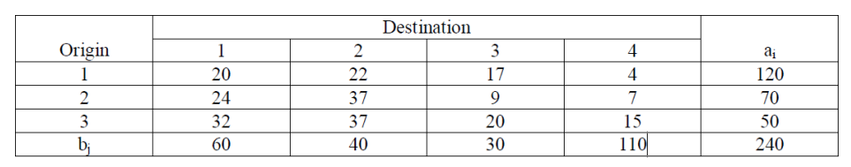 | [7M] | 2 | L3
4. | b) | A workshop contains four people available for work on the four jobs. Only one person can work on any one job. The following table shows the cost of assigning each person to each job. The objective is to assign people to jobs such that the total assignment cost is a minimum.  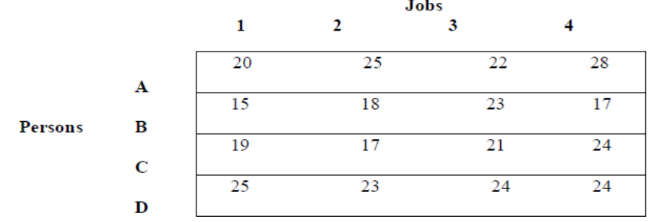 | [7M] | 2 | L3
UNIT-III
5. | a) | Universal Bank is considering opening a drive-in window for customer service. Management estimates that customers will arrive at the rate of 15 per hour. The teller whom it is considering to staff the window can service customers at the rate of one every three minutes. Assuming Poisson arrivals and exponential service find: (i) Average number in the waiting line. (ii) Average number in the system. (iii) Average waiting time in line. (iv) Average waiting time in the system. | [7M] | 3 | L3
5. | b) | There are nine jobs, each of which must go through two machines P and Q in the order PQ, the processing times (in hours) are given below:  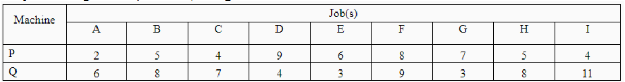  Find the sequence that minimizes the total elapsed time T. Also calculate the total idle time for the machines in this period. | [7M] | 3 | L3
(OR)
6. | a) | A television repairman finds that the time spent on his jobs has an exponential distribution with mean of 30 minutes. If he repairs sets in the order in which they came in, and if the arrival of sets follows a Poisson distribution approximately with an average rate of 10 per 8-hour day, what is the repairman’s expected idle time each day? How many jobs are ahead of the average set just brought in? | [7M] | 3 | L3
6. | b) | Give Johnson’s procedure for determining an optimal sequence for processing ‘n’ items on three machines. | [7M] | 3 | L2
UNIT-IV
7. | a) | Solve the following GAME Graphically:  If necessary, apply dominance principle. | [7M] | 4 | L4
   | Player-A
   |  | I | II | III | IV
  Player-B | I | 2 | 2 | 3 | -2
  Player-B | II | 4 | 3 | 2 | 6
7. | b) | What are the situations which make the replacement of items necessary. | [7M] | 4 | L2
(OR)
8. | a) | Consider a modified form of " matching biased coins" game problem. The matching player is paid Rs. 8.00 if the two coins turn both heads and Rs. 1.00 if the coins turn both tails. The non-matching player is paid Rs. 3.00 when the two coins do not match. Given the choice of being the matching or non-matching player, which one would you choose and what would be your strategy? | [7M] | 4 | L3
8. | b) | A computer contains 10,000 resistors. When any one of the resistor fails, it is replaced. The cost of replacing a single resistor is Rs.10 only. If all the resistors are replaced at the same time, the cost per resistor would be reduced to Rs.3.50. The percent surviving by the end of month t is as follows: | [7M] | 4 | L3
  Month | 0 | 1 | 2 | 3 | 4 | 5 | 6
  % surviving by the end of month | 100 | 97 | 90 | 70 | 30 | 15 | 0
UNIT-V
9. |  | A company manufacturing plant and equipment for chemical processing is in the process of quoting tender called by public sector undertaking. Help the manager to find the project completion time to participate in the tender.  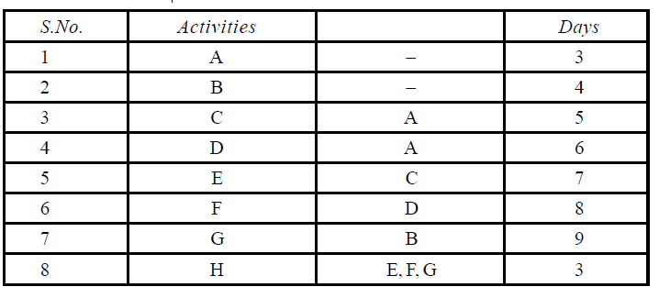 | [14M] | 5 | L3
(OR)
10. |  | A project consists of 4 activities. Their logical relationship and time taken is given along with crash time and cost details. If the indirect cost is Rs. 2000/- per week, find the optimal duration and optimal cost.  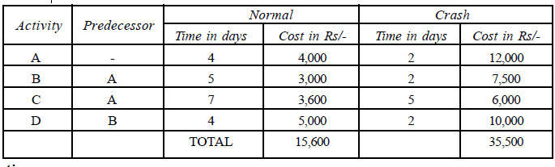 | [14M] | 5 | L4
* * * * ** * * * *
THE ABOVE MODEL PAPER ATTAINMENTS OF BLOOM’S TEXONOMY AS FOLLOWS

L1: 2*7 = 14= 10%
L2: 3*7 = 21 = 15%
L3: (10*7) +(1*14) = 84 = 60%
L4: (1*14) +(1*7) =21 = 15%

SIGNATURES OF

COURSE COORDINATER MODULE COORDINATER HOD

